What-A-Book

TECHNICAL DESIGN DOCUMENT

| **Authors** | Cody Skelton, George Taylor Jr, Joanna Brumfield |
| --- | --- |
| **Last Updated** | 02/27/2024 |
| **Version Number** | 0.2.0 |

**Version History**

| **Name** | **Date** | **Reason For Change** | **Version** |
| --- | --- | --- | --- |
| Skelton, Cody | 02.22.2024 | New document format | 0.1.0 |
| Joanna Brumfield | 02.27.2024 | ORD and noSQL Data Structure | 0.2.0 |
|  |  |  |  |
|  |  |  |  |
|  |  |  |  |
|  |  |  |  |
|  |  |  |  |
|  |  |  |  |
|  |  |  |  |

**SECTION 1: INTRODUCTION** **3**

1.1 Purpose 3

1.2 Terminology 5

1.3 User Personas 5

1.4 User Stories 7

1.5 Time Estimations 9

**SECTION 2: PROCESS DESIGN** **9**

2.1 Prototypes 9

2.2 ORD (Object Relational Diagram(s)) 10

2.3 NoSQL Document Diagram 10

2.4 NoSQL Data Structure 10

**SECTION 3: QA TESTING** **11**

3.1. QA Test Plan 11

3.2. Unit Tests 11

[**SECTION 4: REFERENCES  
SECTION 5: TEAM INFORMATION**](#_isrh67nzedse) **12**

## SECTION 1: INTRODUCTION

### 1.1 Purpose

**Business Goals:**

1. To establish an online presence in order to strengthen and expand WhatABook’s customer base by employing these strategies:
   1. Create an online interface for users where they can browse/favorite/buy ebooks and books in stock at What-A-Book brick and mortar store
   2. Create a database of books currently in stock at WhatABook’s brick and mortar shop as well as ebooks available for download
   3. Create downloadable ebooks for ease of shopping for local and nonlocal customers to help expand customer base
   4. Create a seamless shopping experience by allowing users to:
      1. Search books by genre
      2. Search book by author
      3. Search book by title
      4. Search books by bookId or ISBN
      5. Save favorite books to a wish list collection
      6. Buy ebooks online

**Technical Goals:**

1. Identify e-commerce platforms/APIs to use for digital downloads and secure payments
2. Create database with WhatABook inventory, available ebooks for purchase, and customer information
3. Database will have two collections:
   1. Book Collection:
      1. book_id - (_id)
      2. title - (string)
      3. author - (string)
      4. publisher - (string)
      5. genre - (string)
      6. is_ebook - (bool)
      7. In_stock - (bool)
      8. stock - (int)
      9. price - (double)
   2. Customer Collection:

1. customer_id - (_id)  
 2. username - (string)  
 3. first_name - (string)  
 4. last_name - (string)  
 5. email_address - (string)  
 6. address - (string)  
 7. Zip_code  
 8. wish_list - (array) {

* + - 1. book_id - (_id)
      2. title - (string)
      3. author - (string)
      4. publisher - (string)
      5. genre - (string)
      6. is_ebook - (bool)
      7. In_stock - (bool)
      8. stock - (int)
      9. price - (double)  
         }, {etc.}

1. Create a straightforward easy to navigate user interface up to WCAG standards:
   1. Create header that will have a search bar that customers can use to search by author, ISBN, genre, etc. A dropdown menu with featured genres available, a sign in/account dropdown menu with profile, wishlist, and orders options, and finally a shopping cart link.
   2. Create footer that will have address/phone number to brick and mortar store, links to social profiles, which promote bookstore, etc.
   3. Homepage with easy to locate search features by genre, title, author, and bookId, etc, an “About Us'' and “List of Featured books.”
   4. Signup page for users
   5. Login page for users
   6. Wishlist page when logged in
   7. Page with each books full information and ability to add to cart/wishlist
   8. Page for search by genre
   9. Page for search by author
   10. Page for search by title
   11. Page for search by bookId
   12. Pages for each genre
   13. Shopping cart page
   14. Success/unsuccessful payment after checkout

### 

### 1.2 Terminology

| **Name** | **Comments** |
| --- | --- |
| MEAN Stack | MongoDB, Express, Angular, and Node.js |
| VS Code | Development IDE |
| SoapUI | API testing tool |
| MongoDB Compass | Database development ID |
| Angular Material | https://material.angular.io/ |
| Flex-layout | https://github.com/angular/flex-layout |

### 1.3 User Personas

**Personas 1 -**

1. **Name:** Linda Greene
2. **Age, Gender, Marital Status:** 58, Female, Married for 30 years
3. **Education Level:** High School
4. **Occupation:** Homemaker/Caretaker for parents
5. **Location:** Medium Town, suburbs
6. **Characteristics:** Linda is a devoted wife, mother, and caretaker for her aging parents. Linda married young and created a warm happy home for her family. Since her children have grown and moved away, Linda has a lot more time for her own social pursuits such as hiking groups, book clubs, and gardening clubs. Caring for her aging parents can get slightly stressful at times so she loves to get lost in a good book.
7. **Comfort with Technology:** Can do very basic internet activities such as checking email, shopping, and has a facebook account where she likes to stay updated with her grown children and other relatives. Uses a home computer and a tablet.
8. **Quote: “**I am loyal, caring, while also finally taking time to enjoy my own pursuits”

**Personas 2 -**

1. **Name:** Megan Manner
2. **Age, Gender, Marital Status:** 44, Female, Single
3. **Education Level:** Masters in Teaching and English Literature
4. **Occupation:** High School English Teacher
5. **Location:** Medium sized town but lives in the downtown area as she is very active and social.
6. **Characteristics:**  Megan enjoys healthy activities such as daily walks and yoga classes, enjoys dining out regularly, going to concerts and art galleries, and finding group activities to take part in such as the local community garden, community theater, etc. Megan is head of her book club and a voracious reader.
7. **Comfort with Technology:** Fairly comfortable with familiar technology such as the Word Suit, doing simple spreadsheets, and browsing the web, social media app, and technologies used regularly in her school for grading, etc. Uses a laptop, work computer, tablet, and smart phone regularly.
8. **Quote: “**I am very social, I like to stay busy with healthy and creative pursuits, and also have a very analytical and intelligent side.”

**Personas 3 -**

1. **Name:** Pete Johnson
2. **Age, Gender, Marital Status:** 52, Male, Widowed
3. **Education Level:** Technical School for plumbing
4. **Occupation:** Owns his own small HVAC installation and repair company, has to travel for work several days each month
5. **Location:** Medium Town, Lives on the outskirts on 2 acres
6. **Characteristics:** Pete has always worked very hard running his own company and is known around town as a very gentle, kind, and fair guy. Pete has two loyal dogs he likes to take on walks in the forest around his property in the early evenings before settling in for dinner and sitting on his front porch to read his favorite mystery fiction before bed.
7. **Comfort with Technology:** Comfortable enough to deal with spreadsheets for client jobs, create and email invoices, and do general internet searches and find hobbies groups online. Has a laptop computer, and a smartphone.
8. **Quote: “**I am a simple man and enjoy the simple pleasures of life”

### 1.4 User Stories

**User Stories: As a <User Persona> I want to <Goal> so that <Benefit>.**

**Persona 1: Linda**

| As a user, I want to be able to search for my favorite authors easily so that I don't waste too much time on the computer. | **5** |
| --- | --- |
| As a user, I want to be able to read while taking a bath or relaxing in the garden without carrying around books (i.e. ebooks on my tablet). | **1** |
| As a user, I want to be able to reset my password easily because it's hard to remember them all. I still want to know my information is secure. | **3** |
| As a user, I want to be able to create a collection of books I want to read but cannot afford right now. | **3** |
| As a user, I want to be able to take my library to my parents when I have to stay over to caretake for them without having to pack anything since sometimes I have to head over there on a whim. | **1** |

**Persona 2: Megan**

| As a user I want to be able to have books everywhere I go since I love reading but am also out and about all of the time (ie ebooks). | **1** |
| --- | --- |
| As a user I want to be able to search books easily based on genre, since that is how my book club votes each month. | **3** |
| As a user I want to be able to create a list of my favorite books and books that I think the book club would love the most in a collection before I buy them. | **1** |
| As a user I want to be able to see highly rated books so that I can pick the best books for my book club. | **2** |
| As a user I want to be able to search books by author in case I read a book and am very into the author's voice and content. | **5** |

**Persona 3: Pete**

| As a user, I want to easily be able to filter my favorite books by genre, which is fictional mystery books. | **2** |
| --- | --- |
| As a user, I travel a lot and would love to have my favorite books on my laptop computer so I can read while traveling to make me feel more at home. | **1** |
| As a user I want to be able to login easily without a hassle or worrying about my information getting to hackers. | **5** |
| As a user, I want to be able to filter technical books that I sometimes use on the job for looking at specs and troubleshooting. It would be great if I would access them on my phone. | **1** |
| As a user, I want to be able to compile a list of books I’d like to read in the future. | **3** |

### 1.5 Time Estimations

## SECTION 2: PROCESS DESIGN

### 2.1 Prototypes

1. <https://jb830.github.io/whatAbook-prototype/index.html>  
   This static website mockup website illustrates basic functions for the What-A-Book website user experience (note: “What-A-Book” logo is a link for the homepage)
   1. Click the “Account” dropdown and click “My Profile” to view the “Login page.” From there you can click the “Sign in” button, which will bring you back to index.html (homepage) for the user login experience illustration  
      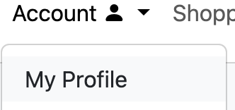
   2. Click the search bar button in the header to see the search by ISBN/bookId illustration

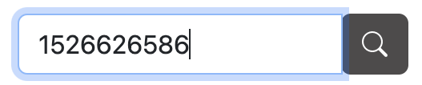

* 1. Click the search button on homepage under in search form on left for an example of search by author illustration  
     
  2. Click the “Add to wishlist” button under each book listing OR “Account” > “My Wishlist” in the header OR the “wishlist” link in the “promotions” sections to view user wishlist illustration  
     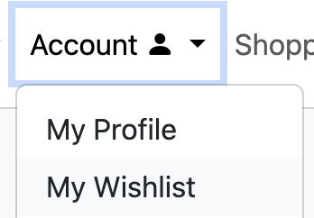
  3. Click on “Book Genres” dropdown menu and click “Action and Adventure” to illustrate search for book by genre  
     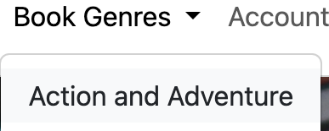
  4. Click “Cart” in the header or “Add to cart” button under each book listing to view the shopping cart page illustration

### 2.2 ORD (Object Relational Diagram(s))

### 

### 2.3 NoSQL Document Diagram Book:

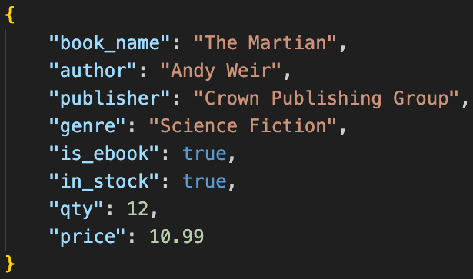

### Customer:

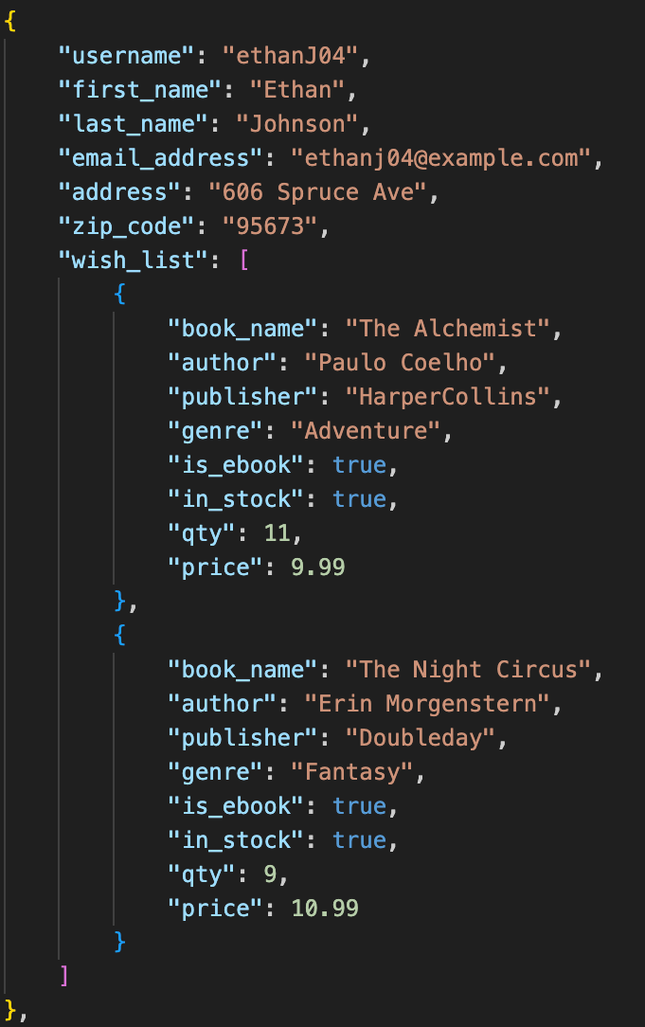

## SECTION 3: QA TESTING

### 3.1. QA Test Plan

### 

### 3.2. Unit Tests

## SECTION 4: REFERENCES SECTION 5: TEAM INFORMATION

Dev-Sphere Designs

**Github Project:** [**https://github.com/Dev-Sphere-Designs/What-a-book**](https://github.com/Dev-Sphere-Designs/What-a-book)

**Team name was chosen because:** Dev and Design encompasses both backend and front end collaboration to create functional and beautiful projects. Despite geographic distance, we work together in a development sphere.

**Mascot:** Rosie The Robot. Rosie The Robot was chosen because she is the perfect blend of precision and playfulness.

**Team Captain:** Joanna Brumfield

**Cody Skelton Bio:** I got introduced to the IT field a few years after the pandemic started dying down. Until that point, I hadn’t found a career field that really interested me. Since then, I’ve studied the IT industry holistically in order to gain an understanding of how everything works together. I knocked out the standard CompTIA degrees right away. I received my Associate’s in Software Development, and am currently going for a Web Development degree through Bellevue University.

As an avid hobbyist, I enjoy researching skillsets where I get to create things. Whether this be carpentry or leatherworking on the physical side, or even web development on the digital side. I enjoy theatrical showcases during Dungeons and Dragons sessions or the haunted house I volunteer for. At some point, I hope my degree of skill in all of these areas culminates into a fantastic experience everyone I create for can enjoy.



**George Taylor Jr Bio:**

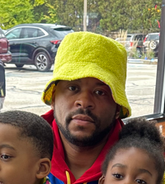

I am currently a student at Bellevue University with a focus in Web Development. A father of two younger children aged 5 and 6 yrs. old. Learning all the required software, rules, procedures, and best practices when building a website is all new to me. I have a degree in 3D animation and design. My goal is to understand all aspects of Web Development so that I can transition those skills in the workplace and to help with my own personal sites.

In my spare time, I help my children with anything from schoolwork to playing make believe games. They are a joy to be around and put a lot of things in perspective. I also do a lot of drawing, 3d animation, and use adobe products. Mostly for original content like characters and story development. I am building my own comic book company. Playing video games and watching movies also take up some of my time but usually I multitask while watching movies. Lastly, I enjoy working out at the gym from running, lifting weights and playing basketball.

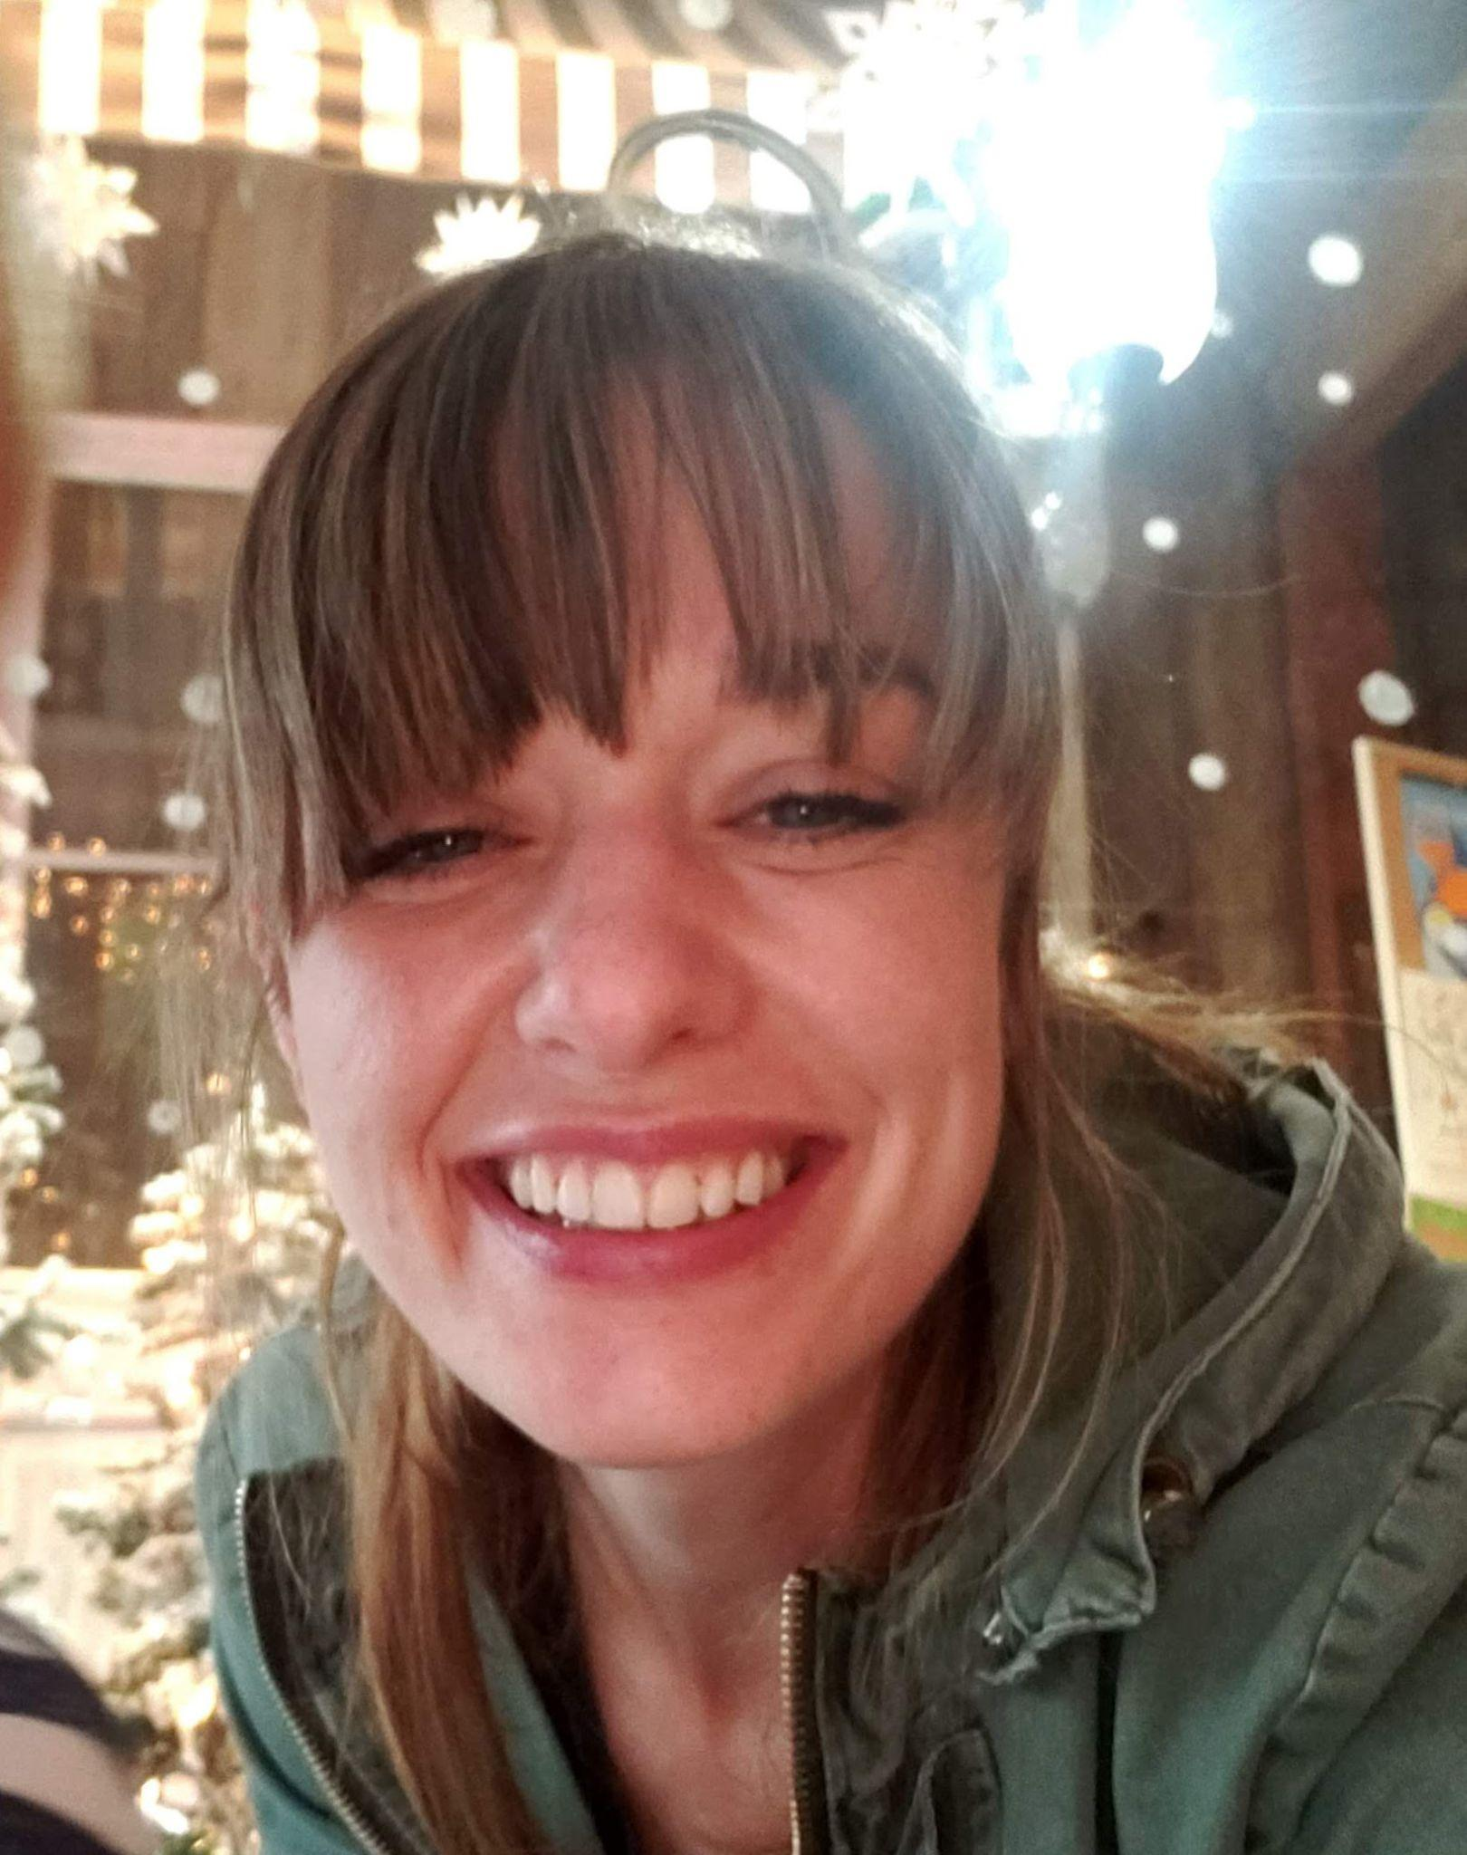

**Joanna Brumfield Bio:** I am a mother, a student, and am in love with all things design. Currently a student at Bellevue University, I am studying Web Development. After becoming a stay-at-home mom I was introduced to building websites with HTML and CSS and it quickly became a hobby as it intertwined my love for design but with an added technical and precise methodology. This hobby ended up inspiring me to pursue a career as a front-end developer and head back to school.

Growing up on a mini-farm in the Sierra Nevada foothills helped instill a deep love for gardening and nature. My family and I now own three acres where we built our first home and have a large variety of fruits, vegetables, and flowers growing any given time of the year. I have many hobbies and interests but for the last year or so my interests have mainly been in floral design, flower farming, plant propagation, and mycology.